Static Friction
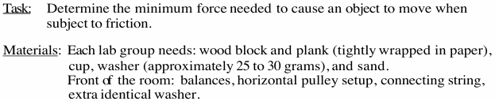

Part 1 Static Friction on a Ramp

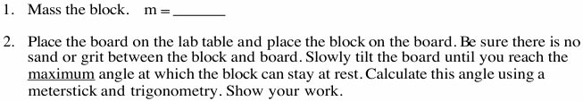

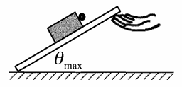
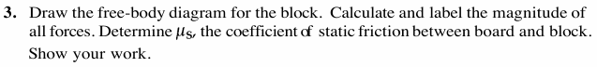

Part 2: Static Friction on a Horizontal Surface

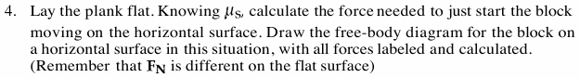

Part 3 Static Friction on a Ramp

